Industrial Internet of Things
Internet of things (IoT) means connecting everyday devices to the internet so they can collect, share and analyse data. Devices may include smartwatches, thermostats, Ac’s, fridges, etc.
Industrial Internet of things (IIoT) is a type of IoT but it mainly focuses on devices being used in industries which may include manufacturing, energy, and transportation. While IoT devices main focus is in convenience and automation IIoT focuses on automating tasks, reducing errors, and predicting maintenance. It handles large of amounts of data and need real time analysis whereas IoT handles smaller, less complex data. Hence, very high security is needed in IIoT devices.
Industrial Internet of Things Architecture
The following three layers are present in IIoT architecture:
- Edge Layer / Device Layer / Perception Layer
Devices like sensors and controllers collect raw data from industrial equipment. Some pre-processing that can be filtering or basic analytics which may be done on edge gateways or microcontrollers. The processed or raw data is transmitted to the cloud using wired or wireless networks.
- Cloud Layer / Network / Data Processing Layer
The cloud stores, aggregates, and analyses the incoming data at scale. All the data from machines (like temperature, pressure, vibration) is saved in the cloud. The cloud organizes this data and the organization may be done by grouping it by machine, time, or location. Advanced analytics and AI/ML algorithms are applied here to the organized data. The cloud turns complex data into easy-to-understand charts, alerts, and reports and these final insights, alerts, and reports are generated and sent to the SOC (Security Operations Centre) or dashboard.
- Application Layer / SOC / Dashboard Layer
It may include SOC (Security Operations Centre) that Monitors IIoT cybersecurity threats or a Dashboards / HMIs used for visualizing interfaces for monitoring KPIs, alerts, and trends. Here visualization of real-time and historical data is done. It acts as a support for operators and engineers to make decisions. It is used for Security monitoring, anomaly detection, and incident response.
If the system is a closed loop system it may even contain a feedback loop. A closed-loop system uses feedback to control itself and improve performance or correct errors. The SOC or dashboard layer might send back control signals or configuration updates down to the edge layer via the cloud.

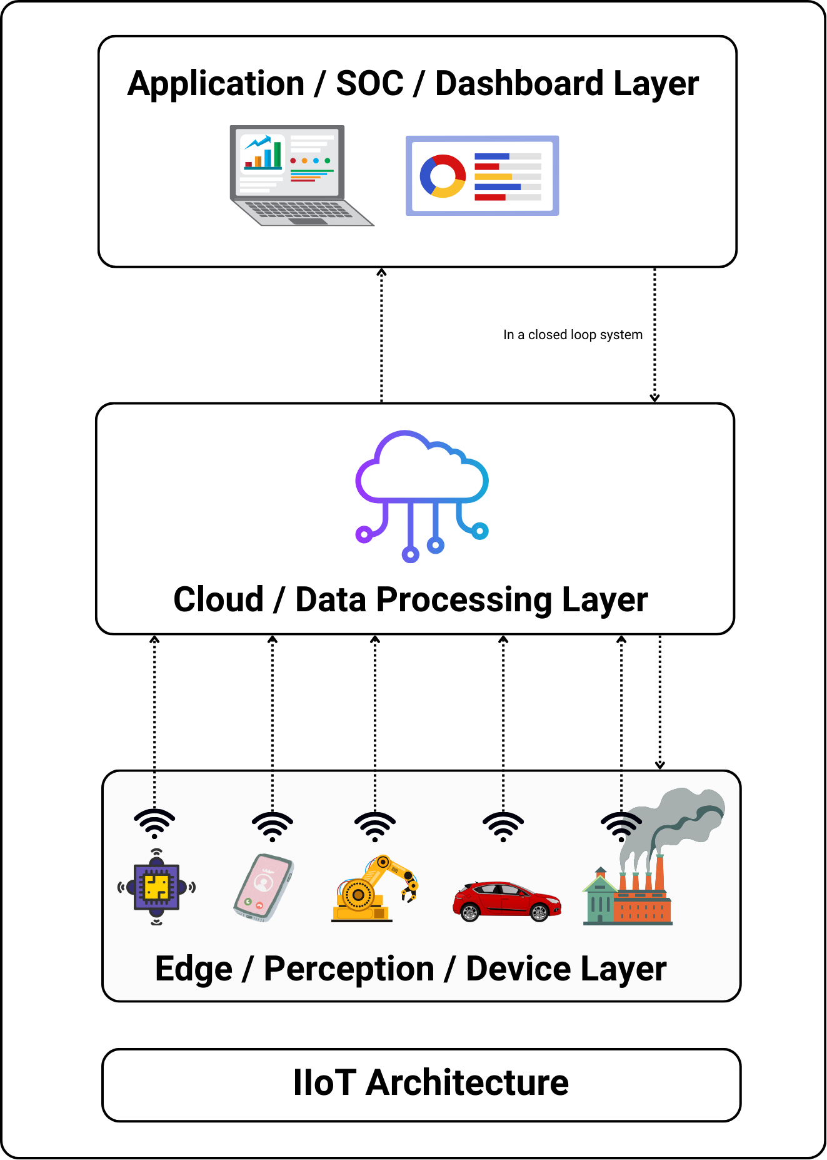

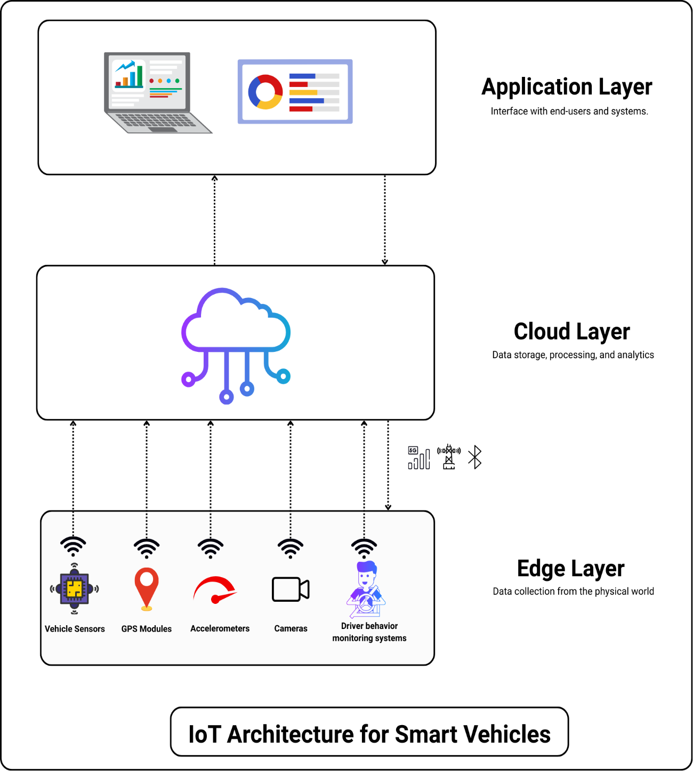

- Application Layer – Interface with end users and systems
Fleet Management Dashboards - Monitors and manages real-time data from multiple vehicles to optimize fleet operations.
Driver Assistance Systems - These are smart features in vehicles like lane-keeping assist, adaptive cruise control, collision warnings, etc.
Autonomous Driving Support - Powers self-driving capabilities by combining local sensors with cloud-based intelligence. Cloud assists with tasks like long-range planning and sharing data between vehicles
Insurance Telematics - Tracks driving behaviour to calculate personalized insurance premiums and reward safe driving.
Public Transportation Optimization - Uses IoT data to improve scheduling, routing, and load management in buses, trains, and metros. Often integrates with passenger mobile apps for real-time tracking.
- Cloud Layer – Store, process and analyse data
Real-time traffic data analytics - Analyses live traffic data from connected sources to detect congestion and suggest faster routes.
Predictive maintenance models - Uses vehicle sensor data to predict when a component is likely to fail.
Incident detection / congestion alerts - Detects accidents, road closures, and bottlenecks by analysing patterns in traffic flow, vehicle speed, and V2X data.
Digital twin simulations for fleet health - Creates a live virtual replica of each vehicle to monitor health and simulate fleet operations.
- Edge Layer – Data collection from the environment.
Vehicle sensors may include Oxygen Sensors, Mass Airflow Sensors, temperature sensors, Engine Oil level sensors, etc.
Cameras & LIDAR (for autonomous driving)
Accelerometers or speed monitors can be used for stability control, accident detection or insurance scoring
GPS modules are used for location tracking
Driver Behaviour Monitoring Systems uses a combination of in-vehicle sensors, cameras, and software algorithms to monitor how a driver operates the vehicle.
Networking - Data transmission between vehicles, cloud and infrastructure.
4G/5G cellular networks
DSRC (Dedicated Short-Range Communications)
V2X (Vehicle-to-Everything) protocols:
V2V (Vehicle-to-Vehicle)
V2I (Vehicle-to-Infrastructure)
V2P (Vehicle-to-Pedestrian)
Wi-Fi / Bluetooth for in-vehicle communications

